Payeer for CMS Modx Revolution 2.4.2-pl (Shopkeeper 3.2.3-pl)

Copy via FTP the assets folder in your site root folder with the replacement files.
Go to the admin panel of the website, go to “Elements” and create a new snippet (right click on section “Snippets”).
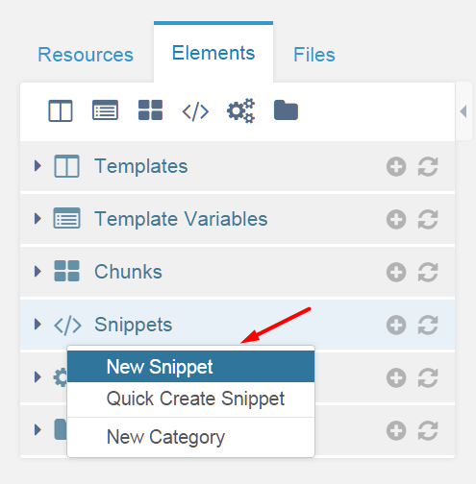

Specify a name and description for the new snippet (Payeer), copy the code from the text file module payeer_snippet.txt in the “snippet Code (php)”. Then click “Save”.
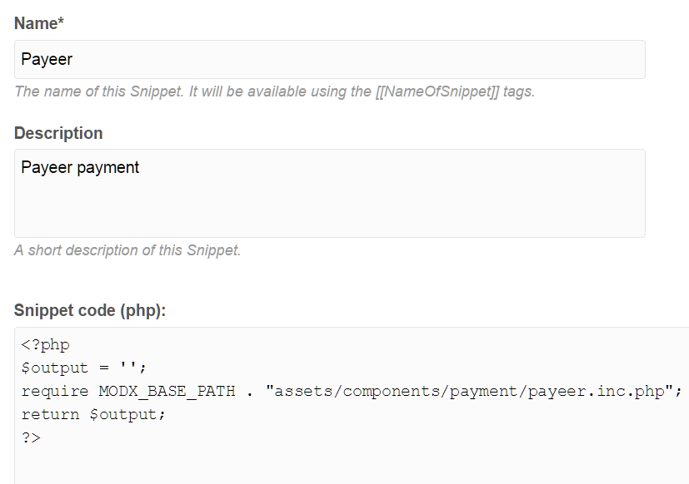
In the control system, edit the page that is opened after placing the order (&redirectTo in FormIt). In the “Content resource” to insert the snippet call: [[!Payeer]]. Click “Save”.
Also check that on the checkout page in the FormIt snippet call had been passed using the &redirectTo. This is the ID of the page that will open after you submit the order.
In the form template should be a dropdown list to select the method of payment.
<select name="payment" class="form-control">
<option value=""></option>
[[!+shkopt_payments]]
</select>

Specify the Payeer module options in the file /assets/components/payment/config/payeer.php
In quotation marks write a blank options:
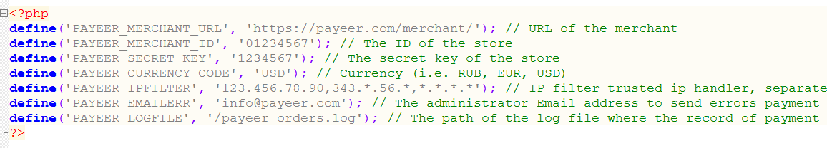

PAYEER_MERCHANT_URL — by default, the path to payment https://payeer.com/merchant/
PAYEER_MERCHANT_ID — store id in the system payeer.com (can be found in the personal cabinet).
PAYEER_SECRET_KEY – the secret key of the store.
PAYEER_CURRENCY_CODE — the currency code of the store in capital letters (RUB, USD or EUR).
PAYEER_IPFILTER – a list of all trusted IP addresses, separated by commas, from which come the requests for verification of payment. You can also specify a mask instead of the IP address. If the field is left blank, the validation is not performed.
For example:
192.168.71.87, 192.165.83.17, 192.178.34.15
Or 192.*.71.87, 192.165.83.*, 192.*.34.15
Or *.*.*.* - all available ip addresses
PAYEER_EMAILERR — an email will be sent notification in case of an error of payment. The letter will state the reason and basic information about the payment.

PAYEER_LOGFILE — if you specify the path to the file logging, you will be recording information about payments via Payeer.

Then, enter the URL address in the “Dasboard → Merchant → Settings”
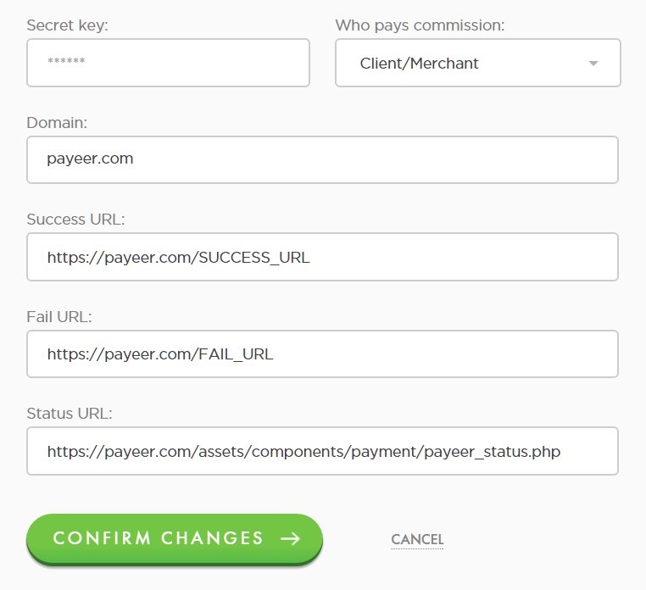

Success URL:
http://*****/SUCCESS_URL
Fail URL:
http://*****/FAIL_URL
Status URL:
http://***** /assets/components/payment/payeer_status.php
Where ***** - this is your domain, SUCCESS_URL – url of the page after successful payment, FAIL_URL link to the page after a failed payment.
Confirm changes.
Module Payeer for CMS Modx Revolution 2.4.2-pl (Shopkeeper 3.2.3-pl) configured.

